The International Water Resource Association (IWRA), Korea Water Resource Corporation (K-water), and Asia Water Council (AWC) are pleased to announce this call for applications to be a pilot city for the Smart Water Cities Project.
14 February 2023
President of the International Water Resources Association

Smart Water Cities Project: Call for Pilot Cities

- General description

The call for Pilot Cities is directed to cities that wish to evaluate and improve the sustainability of their local water services provision and urban water resources management. By participating in the pilot test for the Smart Water Cities project, the selected cities will get a complimentary assessment report, which includes a full diagnosis of the functioning of their urban water systems and a comprehensive proposal on how to improve them, both in terms of the technologies to employ and the measures needed to enhance their local financial, human, and regulatory capacities.

The pilot involves a team of water experts from IWRA and K-water - the Smart Water Cities technical assessment team - reviewing urban water management structures, data, and information systems in the selected cities. With the help and contributions from the local water stakeholders, the assessment team will examine the cities’ water sector performance according to a comprehensive set of indicators, which will offer a complete overview and representation of the strengths and weaknesses of the cities’ urban water resources management and urban water service provision. The pilot assessments will be confidential; results will not be made public without the explicit consent from the cities’ authorities.

To submit a candidacy to the call for Pilot Cities, an application form (Appendix 1) needs to be filled in and sent to m.garcia.quesada@iwra.org. The deadline for the submission of candidacies is 16 April, 2023.

- Overview of Smart Water Cities project

  - Summary

The Call for Pilot Cities is part of the Smart Water Cities Project, which is a joint research project run by IWRA, K-water and the AWC since 2021.

The Smart Water Cities Project’s goal is to develop a tool to measure and compare urban water services provision and urban water management in cities around the world: the Smart Water Cities Index. Such an index will serve to help cities in improving the way they manage their water resources by highlighting areas for improvement and offering an impartial comparison against the management of urban water resources in other existing cities of different scales and economic circumstances, as well as in new cities in development.

  - Purpose of the Call for Pilot Cities
The Call for Pilot Cities will select various cities to examine urban water management practices and water service provision. These assessments will serve to evaluate Pilot Cities’ performance with regards to their water systems, while at the same time helping to improve the robustness of Smart Water Cities Index itself.

- Project Details

The Smart Water Cities Index has been developed by a technical team of experts. It has 114 indicators organised in two main areas: a technical pillar, with 78 indicators, and a Governance and Prospective pillar, with 36 indicators, dedicated respectively to the technical aspects and the institutional and regulatory aspects of providing water services and management of urban water resources. Each pillar is organised into three categories corresponding to different functions and features of cities’ water performance – See Figure below.

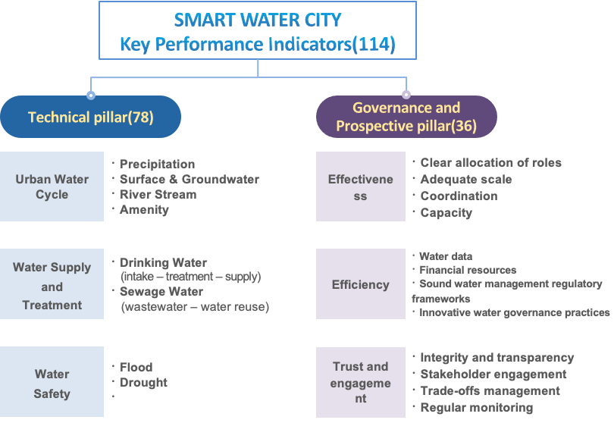

The Technical Pillar is comprised of three sub-categories: Urban Water Cycle, Water Disaster Management, and Water Supply and Treatment. This pillar evaluates the technologies and services implemented by the city to maintain sustainable urban water management with respect to sustainability and smartness. Table 1 presents a selection of the KPIs from the Technical Pillar, for illustrative purposes:

Table 1. Technical pillar: Categories, subcategories and selected KPIs
Categories | Subcategories | Selection of KPIs
Urban Water Cycle | Precipitation | Coverage extent of precipitation observation stations  Precipitation monitoring frequency  Precipitation data automation and real-time transmission  ICT-based rainfall data accessibility  Extension extent of water level observation stations
Urban Water Cycle | Urban stream | Water level monitoring frequency  Coverage extent of urban stream water quality monitoring stations  Urban stream water quality monitoring frequency  Water quality missing data and quality control
Urban Water Cycle | Surface and groundwater | Urban impervious surfaces  Application of LID and green infrastructures  Coverage extent of groundwater observation stations  Application of recycled/reused water  Groundwater observation frequency
Urban Water Cycle | Water amenities | Urban stream ecology maintenance  Amenity water facilities and maintenance  Urban stream biodiversity  Population amenity water satisfaction  Urban stream quality and pollution level
Water Supply and Treatment | Water supply | Drinking water quality monitoring standards and water quality compliance  Real-time water source data collection and management  Pipe leakage  Tap water quality  Smart meter reading
Water Supply and Treatment | Wastewater treatment | Sewage network distribution  Sewage treatment management  Wastewater treatment automation  Aging sewage pipelines  Sewage treatment efficiency
Water Disaster Management | Flood | Flood damage index  ICT-based flood management  Flood risk areas  Real-time smart flood monitoring  Stream flood risk and water level warning standard
Water Disaster Management | Drought | Drought damage index  ICT-based drought management  Water supply and demand during drought events  Drought advanced warning system

The Governance and Prospective pillar, on the other hand, aims to assess the political, economic, and social systems in place at the local level to manage water resources and to deliver water services. It focuses on three categories: Effectiveness, Efficiency and Trust and Governance. Each of them comprises several indicators. Table 2 shows some of the KPIs in the Governance and Prospective Pillar.

Table 2. Governance and Prospective pillar: Categories, subcategories and selected KPIs
Categories | Subcategories | Selection of KPIs
Effectiveness | Clear allocation of roles | Existence of local regulatory powers for water services provision and water resources management
Effectiveness | Adequate scale | Existence and functioning of institutions managing urban water (not necessarily exclusively) at the hydrographic scale
Effectiveness | Coordination | Existence and implementation of mechanisms at the local level to review barriers to policy coherence and/or areas where water and related local practices, policies or regulations are misaligned
Effectiveness | Capacity | Existence and level of implementation of hiring policies based on a merit-based and transparent professional and recruitment process of water professionals independent from political cycles
Efficiency | Water data | Existence and functioning of updates, timely shared, consistent and comparable water information systems at the local level.
Efficiency | Financial resources | Existence and level of implementation of governance arrangements that help local water institutions collect the necessary revenues to meet their mandates and drive water-sustainable and efficient behaviours
Efficiency | Sound water management regulatory frameworks | Existence and level of implementation of regulatory tools to foster the quality of regulatory processes for water management at city level
Efficiency | Innovative water governance practices | Existence and level of implementation of knowledge and experience-sharing mechanisms to bridge the divide between science, policy and practice at the local level
Trust and Engagement | Integrity and transparency | Existence and functioning of independent courts (not necessarily water-specific) and supreme audit institutions that can investigate water-related infringements and safeguard the public interest
Trust and Engagement | Stakeholder engagement | Existence and level of implementation of legal frameworks to engage stakeholders in the design and implementation of local water-related decisions, policies and projects
Trust and Engagement | Trade-offs management | Existence and implementation of mechanisms to manage trade-offs across users, and/or over time in a non-discriminatory, transparent and evidence-based manner at the local level
Trust and Engagement | Regular monitoring | Existence and level of implementation of policy frameworks promoting regular monitoring and evaluation of water policy and governance

- Application and Selection process

  - Applicant organisations
Organisations involved in the management and/or regulation of water resources and water services at the local level are invited to submit their candidacies, either individually or as part of a consortium. This includes entities that are directly responsible for these tasks, such as local and metropolitan authorities, public bodies, water regulators, water operators, etc. Also, research centres, university and non-profit organisations with knowledge and experience in the functioning of water services provision and water resources management in cities are welcome to submit a proposal.

In all cases, participant organisations need to ensure that they have access to, and are entitled to share, data and information concerning the urban water system for the technical assessment team.

  - Application and Criteria for Selection
Cities willing to participate in this call must submit a completed application form – See Appendix 1. Following a review of all the applications, the Steering Committee of the Smart Water Cities Project will select Pilot Cities according to the following main criteria:
- City relevance: The selected cities will be as different as possible to allow for the pilot tests to consider different urban contexts. Questions asked include:
- Is the city’s description comprehensive and complete?
- Are the urban water challenges clearly presented?
- Is water management and water services provision a relevant point in the local agenda?
- Local commitment. During the Pilot City assessment, the applicant organisations need to facilitate an examination of the city’s water systems.
- Are the applicant organisation/s directly responsible for water services provision or water management in city? Are the members of the consortium able to provide support to the technical team undertaking the evaluation?
- Feasibility of the case study:
- Does the city collect and facilitate access to water data and to sources of data and information, including contacts with policy makers and implementers, water users, data records, etc.

  - Schedule (Subject to change)
Following the Pilot City selection, the selected cities, as well as all other non-selected applicants, will be informed of the selection outcome by 5 May 2023.

A Memorandum of Agreement establishing the commitments by the various parties will be signed after the announcement of the selected pilot cities and in advance of the Pilot City study visits.

The Pilot City study visits will take place between June and July 2023, on dates agreed by IWRA, K-water, AWC, and the pilot city representatives.

An Assessment Report will be submitted by IWRA to the city authorities by November 2023.

Milestones for selection and evaluation
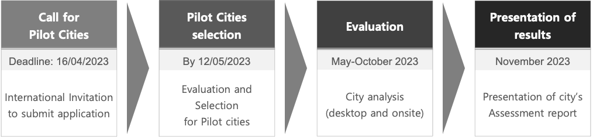
* Schedule might be subject to change

- Confidentiality
The parties will not disclose any information marked, or which may be reasonably considered as confidential, unless such confidential information becomes generally available to the public, or the parties agree in writing that such confidential information may be disclosed.

The Assessment Report resulting from the Pilot City analysis will not be made publicly available unless otherwise agreed with the authorisation of the local Pilot City’s authorities.

- How to Apply
  - Due date (in Central Europe Time)
- April 16th by 18:00 CET, 2023
- For inquiries regarding this call for proposals, please contact IWRA at: m.garcia.quesada@iwra.org

  - Documents
- Refer to Appendix 1 for the Application Form to complete and sign by the head of the applying entity
  - Address for Submission
- The Application Form must be submitted by e-mail to m.garcia.quesada@iwra.org
- Terms and conditions

The city applicants must acknowledge agreement to these basic terms of reference when submitting their applications:

- The selected city’s representatives agree to provide requested information, to the extent that this is available to the Smart Water Cities technical assessment team.
- The selected city’s representatives agree to meet the Smart Water Cities technical assessment team for on-site visit to installations and equipment at the pilot city.
- The selected city’s representatives agree to facilitate the name and contact details of city experts and implementers that can provide information and insight into the management of the city water resources to the Smart Water Cities technical assessment team.
- The selected city’s representatives agree to hold at least two teleconferences at the beginning and at the end of the city assessment periods with the Smart Water Cities technical assessment team.
- The parties agree that none of them incur any responsibility for financial exchange whether in monies or in kind deriving from this agreement.
- The Assessment report on the Pilot City’s water management status, as well as all information submitted to support the assessment, are strictly confidential. The results deriving from the assessment will not be made public without the expressed consent of the City’s representatives.

- About
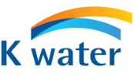
K-water is a government-owned corporation for comprehensive water resource development, providing both public and industrial water in the Republic of Korea. Established in 1967, K-water has a large pool of practical engineering expertise regarding water resources and has championed smart water technologies for several years.

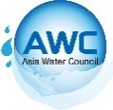
The AWC is a non-profit, non-governmental, and innovative regional cooperation organization established in 2015. The AWC’s core value is to solve water issues faced in Asia and aims to seek scientific and technological solutions as well as concrete implementation plans.


IWRA is a non-profit, non-governmental, international member-based Association established in 1971. It provides a global, knowledge and research-based forum working at the interface of science and policy for the sustainable use and management of the world’s water resources.

The IWRA Executive Office is happy to answer any questions. Please contact:

 |  |  | IWRA Executive Office,  21, rue de Madrid 75008  Paris, France | Tel: +33-6-44-20-57-53  Email: office@iwra.org
Appendix 1 |  | Application Form

APPLICATION
Title:* □ Mr. □ Ms. □ Prof. □ Dr.
First Name:* |  |  | Last Name:*
Organization/Affiliation Name:*
_______________________________________________________________________________________________________
Main Contact(s) name(s) and affiliation(s):*

Type of Organization:*
□ Government/Local government
□ International Organization
□ Public Corporation
□ Academia, Research Institute
□ Industry
□ CSO (Civil Society Organization, NGO)
□ Other ( )
Country:* | Telephone:*  (Incl. Country Code) |  |  | E-mail:*

All fields marked with an asterisk (*) are mandatory.
Please do not hesitate to expand any of the section onto extra pages if you need additional space.

- Applicant organisation/s:*
Describe the applicant organisation: type of organisation, roles and responsibilities on water service provision and/or water resources management, number of employees, established networks and cooperation with local water stakeholders, etc.

- Background and context of the city:*
Describe the characteristics of the city, including – not limited to - information to the following points

- Old or new city
- City population
- Density of city population
- City population growth
- City physical geography
- City climate
- Water consumption
- Gross Domestic Product (GDP) in USD

- Activities to support the Smart Water Cities technical assessment team:*
Indicate the initiatives that your organisation proposes to support and facilitate the information gathering tasks by the Smart Water Cities assessment team. Suggestions include but are not limited to: Facilitating meetings with responsible units and responsible actors, visits to infrastructures, aid to access to relevant legislation and archives, etc.

Approved and signed by: | Signature:
(Name and title of Responsible of Applying entity)

Date:_______/_______/_____________

